Assignment 8
Please read turn-in checklist at the end of this document before you start doing exercises.
Section 1: Pen-and-paper Exercises
- A heap can be stored as an array A.
- Root of tree is A[0]
- Left child of A[i] = A[2i+1]
- Right child of A[i] = A[2i + 2]
- Parent of A[i] = A[ (i-1)/2✗ ]
- The elements in the subarray A[(n/2✗) … (n-1)] are leaves

Following the algorithms above, what would be the array representation of the max-heap below? (5 points)
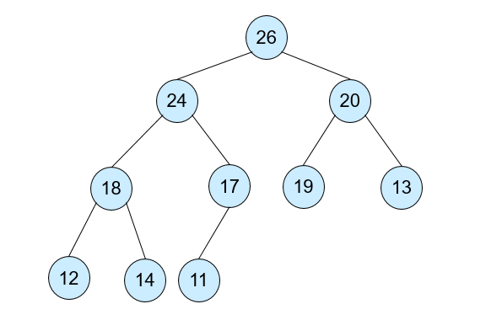
A[ ] = [26, 24, 20, 18, 17, 19, 13, 12, 14, 11]

- Explain how HeapSort sorts {3, 1, 6, 5, 2, 4}. Show all the steps (5 points).

Inserted below is a paper going through each step of heap sort. To help me visualize the tree I first turned the array into a heap so I had the tree to start with. The bottom half of the page under the dashed line is the heap sort. Start by taking away the root of the tree (1) and replacing it with the largest value in the tree (6). The 1 is now out of the tree since it is sorted so we have {1}. 6 was placed at the root of the tree but it needs to be updated since it is the largest, thus 6 moves to where 3 was, 3 moves to where 2 was and 2 moves to where 6 was. That was one cycle of sorting so now the process starts again, remove the root (2) and add it to our list {2,1} and move 6 into the root. Then updated it so the tree order is correct again. This gets repeated until the last node is sorted giving us the finished heapsort.
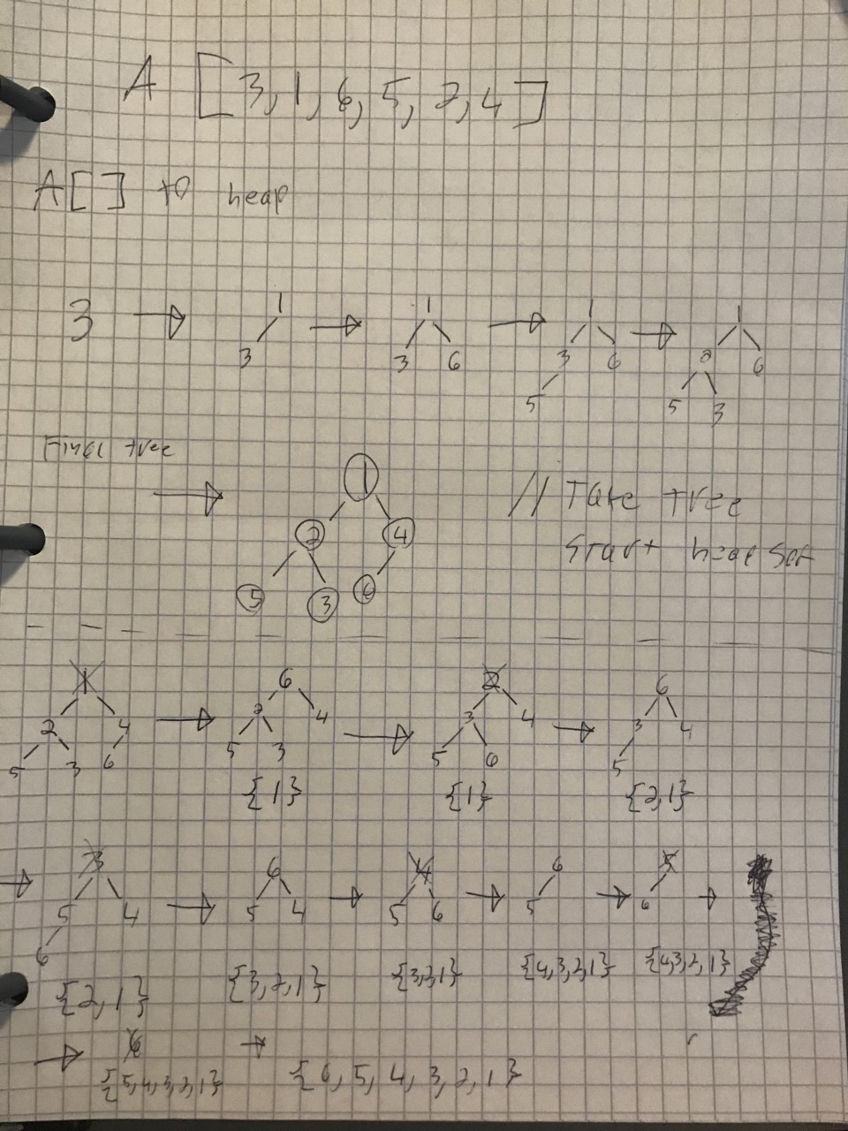

- Here is an adjacency list representation of a directed graph where there are no weights assigned to the edges).

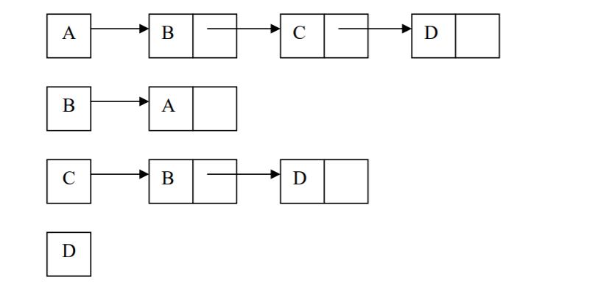
- Draw a picture of the directed graph that has the above adjacency list representation (5 points).
- Another way to represent a graph is an adjacency matrix. Draw the adjacency matrix for this graph (5 points).

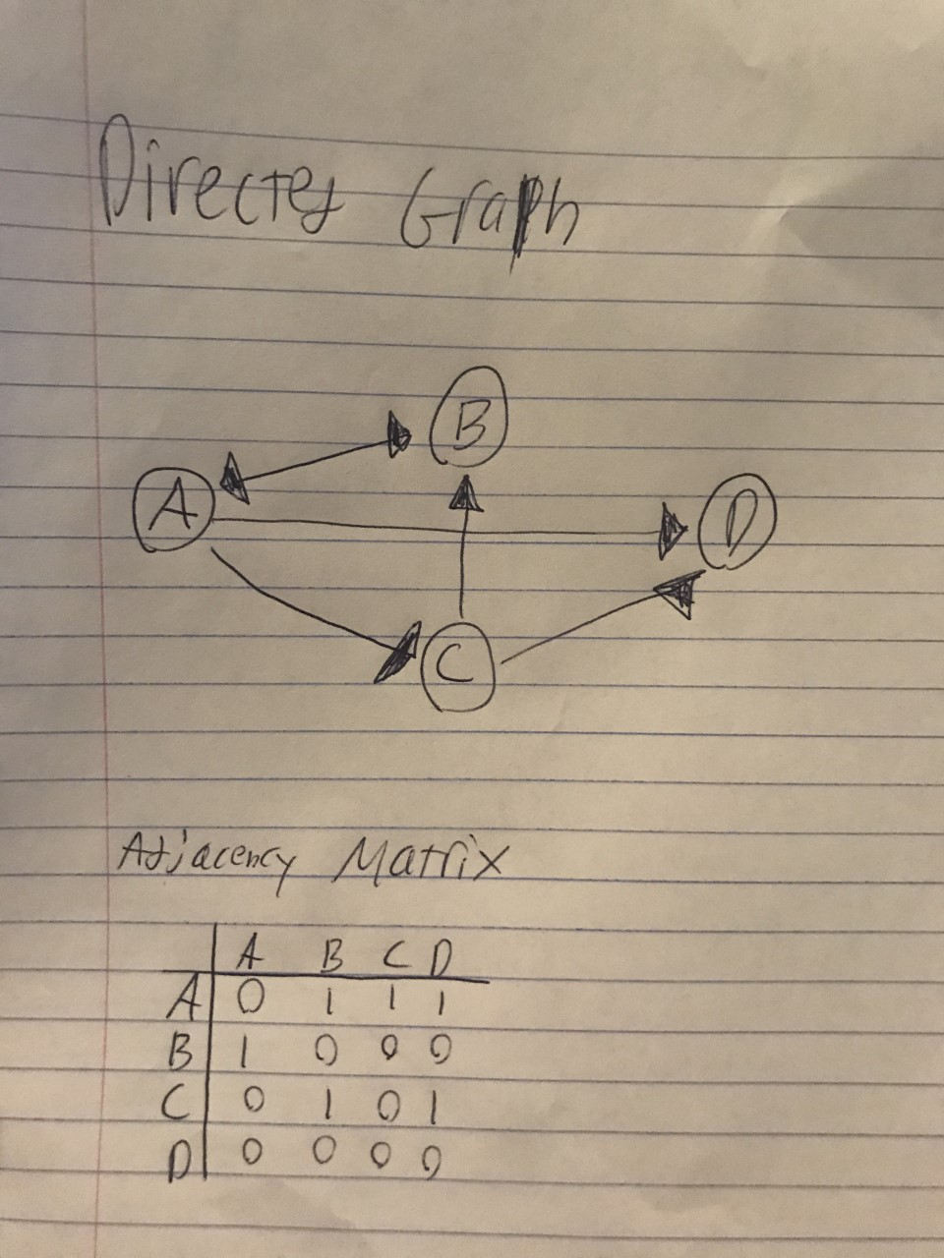

- Given a directed graph, how to check if there is a cycle in the graph?
(i) describe the idea behind your algorithm in English (2 points);
First use a short loop to make sure that wasVisted is set to false for the whole vertex list and also set all of the cycle flags back to -1 since those are the initial values. Then we pick a starting node and we can have it run through using each vertex as a starting node if we want. Then we need to visit the starting node which means we have to change wasVisted to true, set cycle flag to 0, display the vertex (so we can see it print), then push it to the stack. Then we begin a while loop (!theStack.isEmpty()). First we declare neighbor by setting it equal to getAdjUnvisitedVertex(theStack.peek()). If the neighbor doesn’t equal -1 then we have 3 options: if cycleflag is -1, else if cycle flag is 0, else cycle flag is 1. If the cycle flag is -1 we push neighbor to the stack, set vertexcycleflag to 0, set was visited to true, set vertexlist cycle flag to 0, display vertex and print the stack. If the cycle flag was 0 that means there was a cycle so you display vertex and print the stack. If the cycle flag was 1, was visited is true and cycle flags go to 1, displayvertex and pop the stack. If the neighbor is -1 these 3 options don’t happen and we return false. If every thing fails there is no cycle and we return false.
(ii) provide pseudocode (5 points);
For loop
vertexList.wasVisted = false; //resets was visited
vertexcycleflag = -1; //set all nodes back to -1
end loop

// Very similar to dfs
//Pick the starting node
For loop (i=0; i<nVerts; i++) //for each vertex
randNum = i;

//Visit the starting node
vertexList.wasVisited = true;
vertexcycleflag = 0; //finishing cycle
displayVertex;
theStack.push(randNum);

while (!theStack.isEmpty()) {
int neighbor = getAdjUnvisitedVertex(theStack.peek());
if(neighbor != -1) { // initial value
if (vertexcycleflag[neighbor] == -1)
theStack.push(neighbor);
vertexcycleflag[neighbor] = 0;
vertexList[neighbor].wasVisited = true;
vertexList[neighbor].cycleflag = 0;
displayVertex(neighbor);
print theStack;
End if
else if(vertexcycleflag[neighbor] == 0 )
displayVertex(neighbor);
return true;
end if
else
vertexList[neighbor].wasVisited = true;
vertexList[neighbor].cycleflag = 1;
vertexcycleflag[neighbor] = 1;
displayVertex(neighbor);
theStack.pop();
end else
end if
else
return false;
end else
end while
end for loop
return false //means there was no cycle found

(iii) analyze its running time (3 points).
O(n) in general but it is based of the vertices so it is more accurately O(v)

Section 2: Java Implementation
- Create an adjacency list to represent the following graph in Java (30 points).

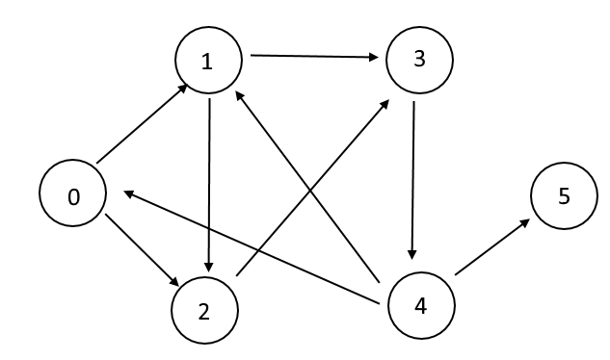
Note:
Find a file called Graph.java in assignment 8 folder.
Complete the main method to represent the given graph and print its adjacency list.
Test your method in the main method provided following the comments.

- Following problem 5, implement problem 4 in Java to find cycles in the given graph (30 points).
Note:
Find a file called Graph.java in assignment 8 folder.
Complete the method of detectcycle().
Test your method in the main method provided following the comments.

TURN-IN CHECKLIST:

- Answers to Section 1 (.doc/.txt/.pdf), and to Section 2 (all your source Code (.java files)). Remember to include your name, the date, and the course number in comments near the beginning of your code/report.

- Create a folder and name it 'FirstName_LastName_assignment_8'. In the newly created folder copy and paste your files (.doc/.txt/.java files). Then compress the folder, and push it to iLearn.

